NETWORK_DESIGN_MOHAMMEDZAIN
Design and Implementation of a Hospital System Network Design.
Network Design: 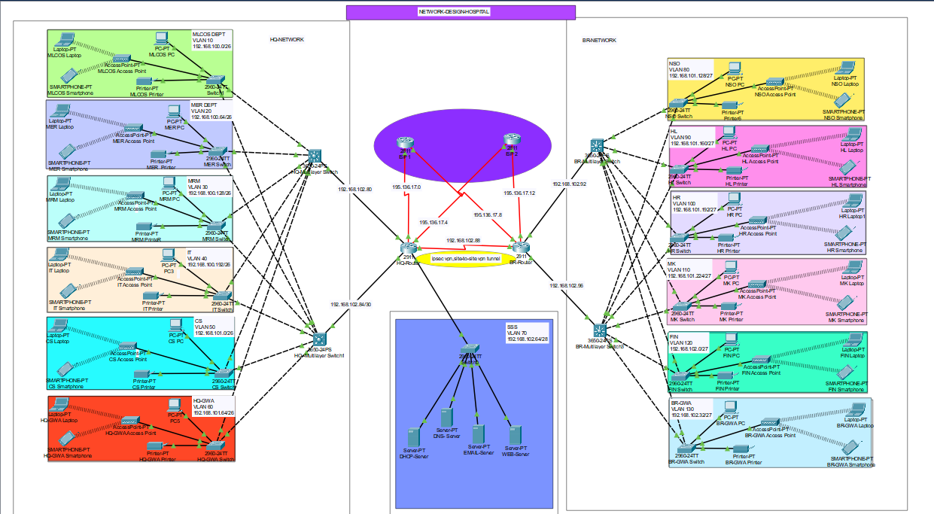
Network Architecture Overview:
I designed a hierarchical network model featuring built-in redundancy to ensure High Availability (fault tolerance) and optimized Load Balancing for peak performance.
Core Infrastructure:
- Site Design: Each site utilizes a three-tier architecture consisting of one Core Router, two Multilayer Switches (Distribution layer), and multiple Access Switches dedicated to specific departments.
- Connectivity: The HQ and Branch networks are linked via a Serial Connection for site-to-site communication.
- Wireless: Integrated wireless networking is available for users across all departments.

VLAN Segmentation & Departments:
The network is logically segmented into 13 VLANs to enhance security and manage traffic

Location | Departments | VLAN IDs
HQ Network | MLOCS, MER, MRM, IT, CS, HQ-GWA | 10, 20, 30, 40, 50, 60
Branch Network | NS0, HL, HR, MK, FIN, BR-GWA | 80, 90, 100, 110, 120, 130
Server-side-site  (SSS) | DHCP, DNS, Email, and Web Servers | 70

IP Addressing:
HQ Hospital IP Addressing
Base Network: 192.168.100.0

Department | Network Address | Subnet Mask | Host Address Range | Broadcast Address
MLOCS | 192.168.100.0 | 255.255.255.192/26 | 192.168.100.1 to 192.168.100.62 | 192.168.100.63
MER | 192.168.100.64 | 255.255.255.192/26 | 192.168.100.65 to 192.168.100.126 | 192.168.100.127
MRM | 192.168.100.128 | 255.255.255.192/26 | 192.168.100.129 to 192.168.100.190 | 192.168.100.191
IT | 192.168.100.192 | 255.255.255.192/26 | 192.168.100.193 to 192.168.100.254 | 192.168.100.255
CS | 192.168.101.0 | 255.255.255.192/26 | 192.168.101.1 to 192.168.101.62 | 192.168.101.63
GWA | 192.168.101.64 | 255.255.255.192/26 | 192.168.101.64 to 192.168.101.126 | 192.168.101.127

Branch Hospital IP Addressing:
Department | Network Address | Subnet Mask | Host Address Range | Broadcast Address
NSO | 192.168.101.128 | 255.255.255.224/27 | 192.168.101.129 to 192.168.101.158 | 192.168.101.159
HL | 192.168.101.160 | 255.255.255.224/27 | 192.168.101.161 to 192.168.101.190 | 192.168.101.191
HR | 192.168.101.192 | 255.255.255.224/27 | 192.168.101.193 to 192.168.101.222 | 192.168.101.223
MK | 192.168.101.224 | 255.255.255.224/27 | 192.168.101.225 to 192.168.101.254 | 192.168.101.255
FIN | 192.168.102.0 | 255.255.255.224/27 | 192.168.102.1 to 192.168.102.30 | 192.168.102.31
GWA | 192.168.102.32 | 255.255.255.224/27 | 192.168.102.33 to 192.168.102.62 | 192.168.102.63

Server-Side Site (SSS):
Department | Network Address | Subnet Mask | Host Address Range | Broadcast Address
SSS | 192.168.102.64 | 255.255.255.240/28 | 192.168.102.65 – 192.168.102.78 | 192.168.102.79

Link Infrastructure & IP Allocation
Router to Layer-3 Switch Interconnects
- These point-to-point links use a /30 mask, providing two usable IP addresses per connection—ideal for connecting routers to multilayer switches.
Connection ID | Device Link | Network Address
1 | HQR1 to HQMLSW1 | 192.168.102.80/30
2 | HQR1 to HQMLSW2 | 192.168.102.84/30
3 | BRR1 to BRMLSW1 | 192.168.102.88/30
4 | BRR1 to BRMLSW2* | 192.168.102.92/30
5 | HQR1 to BRR1 | 192.168.102.96/30

Between the Routers and ISPs:
- Public IP addresses: 195.136.17.0/30, 195.136.17.4/30, 195.136.17.8/30, and 195.136.17.12/30.

CONFIGURATION:
- Department MLOCS:
HOSTNAME – MLOS-SW, MLCOS PRINTER
PASSWORD – MLOCSS
- Department MER:
HOSTNAME – MER-SW, MER PRINTER
PASSWORD – MERR
- Department MRM:
HOSTNAME –MRM-SW, MRM PRINTER
PASSWORD – MRMM
- Department IT:
HOSTNAME – IT-SW, IT PRINTER
PASSWORD – ITT
- Department CS:
HOSTNAME – CS-SW, CS PRINTER
PASSWORD – CSS
- Department HQ-GWA:
HOSTNAME – HQ-GWA-SW, HQ-GWA PRINTER
PASSWORD – HQ-GWAA
- Department SSS:
HOSTNAME – SSS-SW, SSS PRINTER
PASSWORD – SSS
- Department NSO:
HOSTNAME – NSO-SW, NSO PRINTER
PASSWORD – NSOO
- Department HL:
HOSTNAME – HL-SW, HL PRINTER
PASSWORD – HLL
- Department HR:
HOSTNAME – HR-SW, HR PRINTER
PASSWORD – HR
- Department MK:
HOSTNAME –MK-SW, MK PRINTER
PASSWORD – MK
- Department FIN:
HOSTNAME –FIN-SW, FIN PRINTER
PASSWORD – FIN
- Department BR-GWA:
HOSTNAME –BR-GWA-SW, BR-GWA PRINTER
PASSWORD – BR-GWAA
- HQ-MULTILAYER-SW:
HOSTNAME – HQ-MULTILAYER-SW
PASSWORD – HQ-ML
- HQ-MULTILAYER-SW2:
HOSTNAME – HQ-MULTILAYER-SW2
PASSWORD – HQ-MLL
- BR-MULTILAYER-SW:
HOSTNAME – BR-MULTILAYER-SW
PASSWORD – BR-ML
- BR-MULTILAYER-SW2:
HOSTNAME – BR-MULTILAYER-SW2
PASSWORD – BR-MLL
- HQ-ROUTER:
HOSTNAME – HQ-ROUTER
PASSWORD – HQ-ROUTERR
- BR-ROUTER:
HOSTNAME – BR-ROUTER
PASSWORD – BR-ROUTERR

Technologies Implemented:
- Routing Protocols:
- OSPF (Single-Area 10):
OSPF 10 is done on the routers and the multilayer switches.
IN HQ-MULTILAYER SWITCH1:
- IP routing
- OSPF 10
- Network 192.168.100.0 0.0.0.63 area 0
- Network 192.168.100.64 0.0.0.63 area 0
- Network 192.168.100.128 0.0.0.63 area 0
- Network 192.168.100.192 0.0.0.63 area 0
- Network 192.168.101.0 0.0.0.63 area 0
- Network 192.168.101.64 0.0.0.63 area 0
- Network 192.168.102.80 0.0.0.3 area 0
IN HQ-MULTILAYER SWITCH2:
- IP routing
- OSPF 10
- Network 192.168.100.0 0.0.0.63 area 0
- Network 192.168.100.64 0.0.0.63 area 0
- Network 192.168.100.128 0.0.0.63 area 0
- Network 192.168.100.192 0.0.0.63 area 0
- Network 192.168.101.0 0.0.0.63 area 0
- Network 192.168.101.64 0.0.0.63 area 0
- Network 192.168.102.84 0.0.0.3 area 0
IN BR-MULTILAYER SWITCH1:
- IP routing
- OSPF 10
- Network 192.168.101.128 0.0.0.31 area 0
- Network 192.168.101.160 0.0.0.31 area 0
- Network 192.168.101.192 0.0.0.31 area 0
- Network 192.168.101.224 0.0.0.31 area 0
- Network 192.168.102.0 0.0.0.31 area 0
- Network 192.168.102.32 0.0.0.31 area 0
- Network 192.168.102.92 0.0.0.31 area 0
IN BR-MULTILAYER SWITCH2:
- IP routing
- OSPF 10
- Network 192.168.101.128 0.0.0.31 area 0
- Network 192.168.101.160 0.0.0.31 area 0
- Network 192.168.101.192 0.0.0.31 area 0
- Network 192.168.101.224 0.0.0.31 area 0
- Network 192.168.102.0 0.0.0.31 area 0
- Network 192.168.102.32 0.0.0.31 area 0
- Network 192.168.102.96 0.0.0.31 area 0
IN HQ- ROUTER:
- OSPF 10
- Network 192.168.102.80 0.0.0.3 area 0
- Network 192.168.102.84 0.0.0.3 area 0
- Network 192.168.102.64 0.0.0.15 area 0
- Network 192.168.102.88 0.0.0.3 area 0
- Network 195.136.17.4 0.0.0.3 area 0
- Network 195.136.17.0 0.0.0.3 area 0
IN BR- ROUTER:
- OSPF 10
- Network 192.168.102.96 0.0.0.3 area 0
- Network 192.168.102.88 0.0.0.3 area 0
- Network 195.136.17.8 0.0.0.3 area 0
- Network 195.136.17.12 0.0.0.3 area 0
IN ISP1- ROUTER:
- OSPF 10
- Network 195.136.17.8 0.0.0.3 area 0
- Network 195.136.17.0 0.0.0.3 area 0
IN ISP2- ROUTER:
- Network 195.136.17.4 0.0.0.3 area 0
- Network 195.136.17.12 0.0.0.3 area 0

DEFAULT STATIC ROUTE:
- IN HQ-MULTILAYER SWITCH1:

- Ip route 0.0.0.0 0.0.0.0 192.168.102.82

- IN HQ-MULTILAYER SWITCH2:

- Ip route 0.0.0.0 0.0.0.0 192.168.102.86

- IN BR-MULTILAYER SWITCH1:

- Ip route 0.0.0.0 0.0.0.0 192.168.102.94

- IN BR-MULTILAYER SWITCH2:

- Ip route 0.0.0.0 0.0.0.0 192.168.102.98

- IN HQ- ROUTER:

- Ip route 0.0.0.0 0.0.0.0 195.136.17.2
- Ip route 0.0.0.0 0.0.0.0 195.136.17.6 70

- IN BR- ROUTER:

- Ip route 0.0.0.0 0.0.0.0 195.136.17.14
- Ip route 0.0.0.0 0.0.0.0 195.136.17.10 70

NAT/PAT :
  - NAT for internet access
  - I configured NAT on HR-ROUTER and BR-ROUTER
  - Configured port address translator on both HQ-ROUTER AND BR-ROUTER
  - So that it can be translate into public Ip address

IN HQ- ROUTER:
- Int se0/1/0 - Ip Nat outside
- Int se0/2/1 – Ip Nat outside
- Int range gig0/0-2 – Ip Nat inside
- Ip Nat inside source list 1 interface se0/2/1 overload
- Ip Nat inside source list 1 interface se0/1/0 overload

IN BR- ROUTER:
- Int se0/1/1 - Ip Nat outside
- Int se0/2/0 - Ip Nat outside
- Int range gig0/0-1 – Ip Nat inside
- Ip Nat inside source list 1 interface se0/1/1 overload
- Ip Nat inside source list 1 interface se0/2/0 overload

Access Control list:
IN HQ- ROUTER:
- Access-list 1 permit 192.168.100.0 0.0.0.63
- Access-list 1 permit 192.168.100.64 0.0.0.63
- Access-list 1 permit 192.168.100.128 0.0.0.63
- Access-list 1 permit 192.168.100.192 0.0.0.63
- Access-list 1 permit 192.168.101.0 0.0.0.63
- Access-list 1 permit 192.168.101.64 0.0.0.63
IN BR- ROUTER:
- Access-list 1 permit 192.168.101.128 0.0.0.31
- Access-list 1 permit 192.168.101.160 0.0.0.31
- Access-list 1 permit 192.168.101.192 0.0.0.31
- Access-list 1 permit 192.168.101.224 0.0.0.31
- Access-list 1 permit 192.168.102.0 0.0.0.31
- Access-list 1 permit 192.168.102.32 0.0.0.31
Site-to-Site IPSec VPN:
- IPSec VPN tunnels form HQ-ROUTER to BR-ROUTER for secure communication
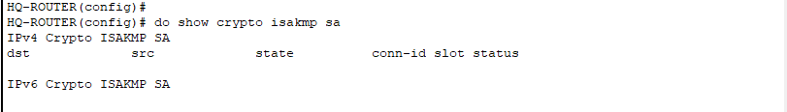
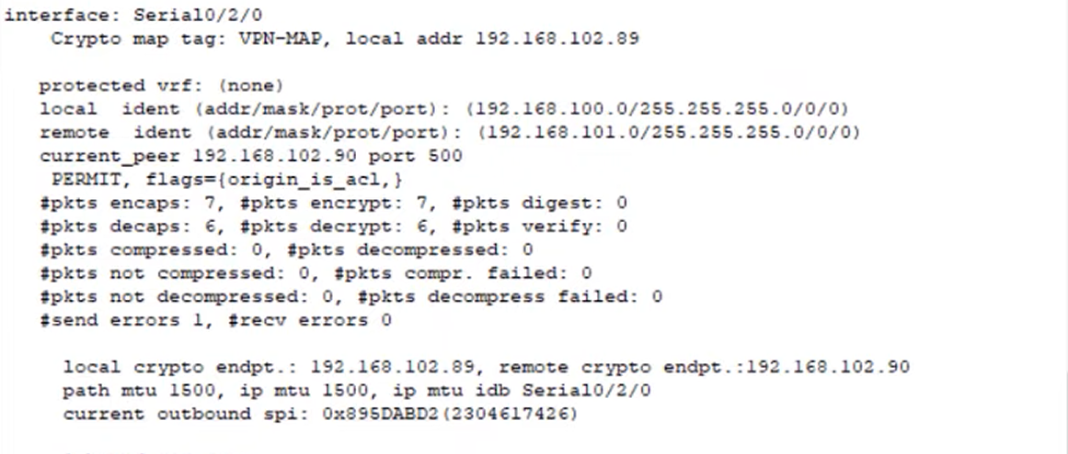
VLANs & Inter-VLAN Routing:
- Inter-VLAN routing using Layer 3 switches

SSH and Port Security:
- Port security is done in server-side-site switch

DHCP, DNS, and Server Configurations:
- DHCP for dynamic IP allocation
- DNS for internal name resolution

Wireless Networking:
- Access Points for each department
- SSID configurations per VL

